#. Install the git and check the version.( if git is already installed )

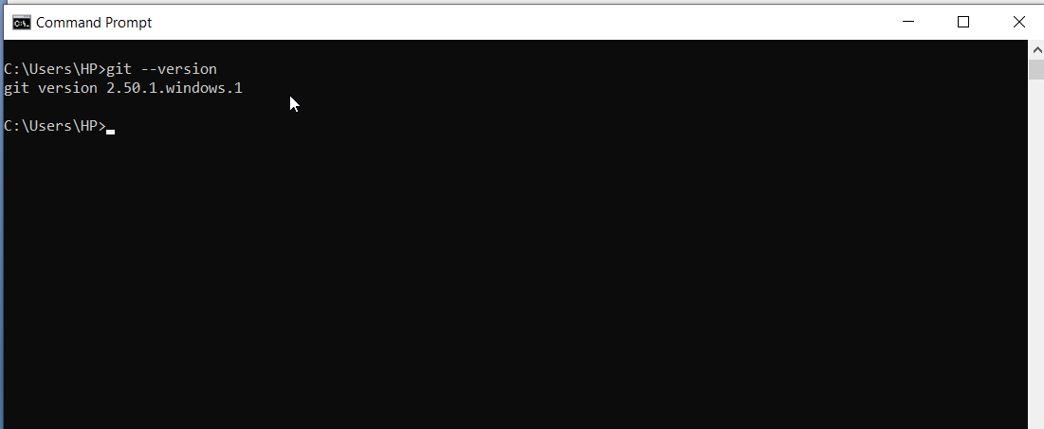

#. Create GitHub Account and Login into Github

#. Create one Folder called “MyProject”.

#. Right Click on the Folder>Open Git Bash.

#. Configure email id and username

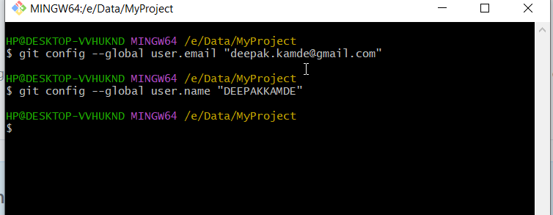

#. Initialize the git init.

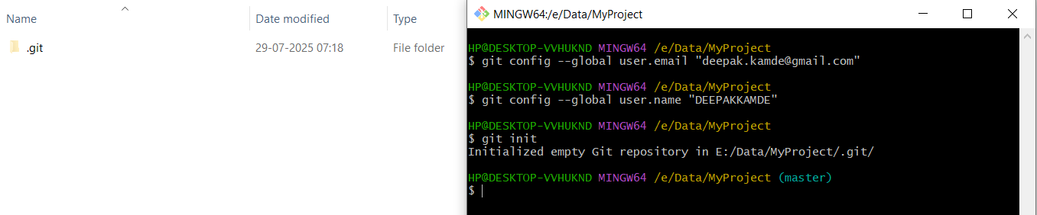

#. Add file in the folder.

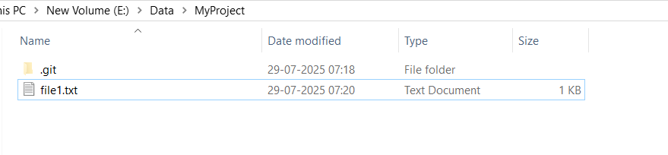

Run Git status and add the file.

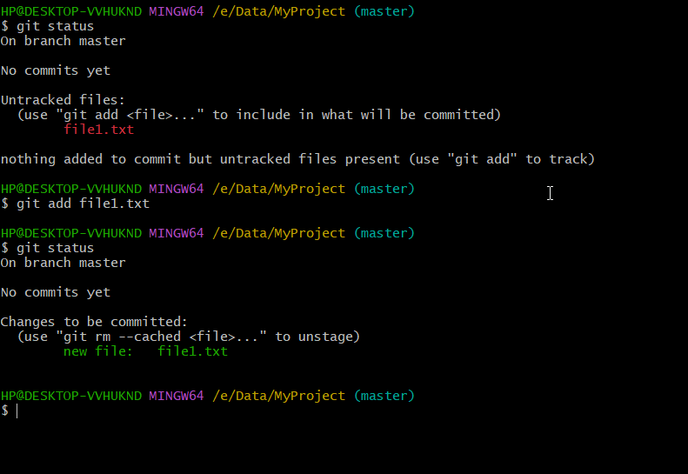

Run Command git commit

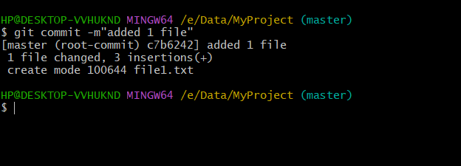

#. Add the remote repo url

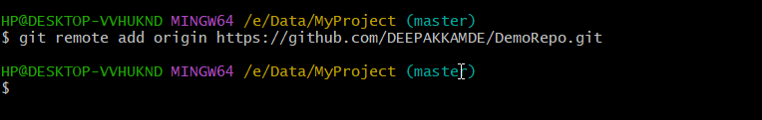

#. Push to master origin

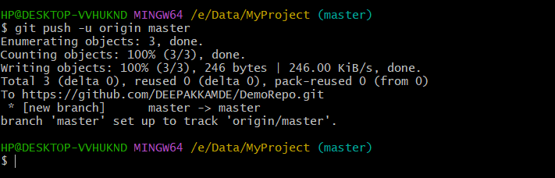

#. Git push and log

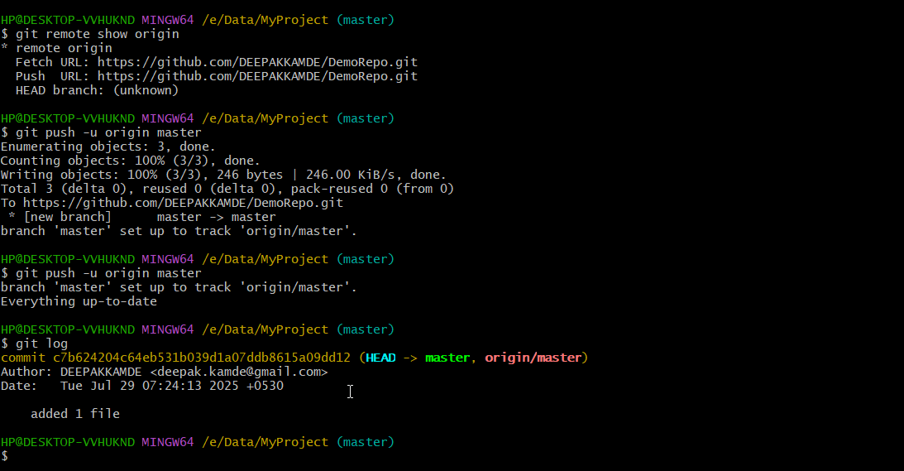

**Git Branches**

**#. Create Branch and list all branches**

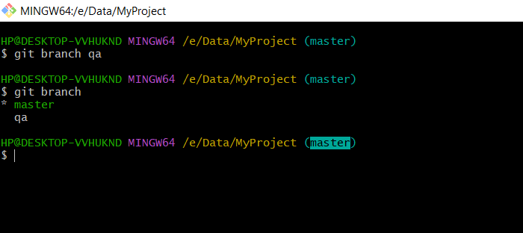

#. Switch to qa branch

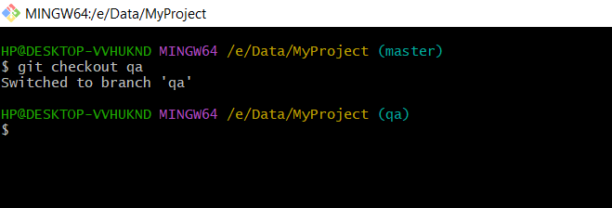

#. Craete file2.txt in QA

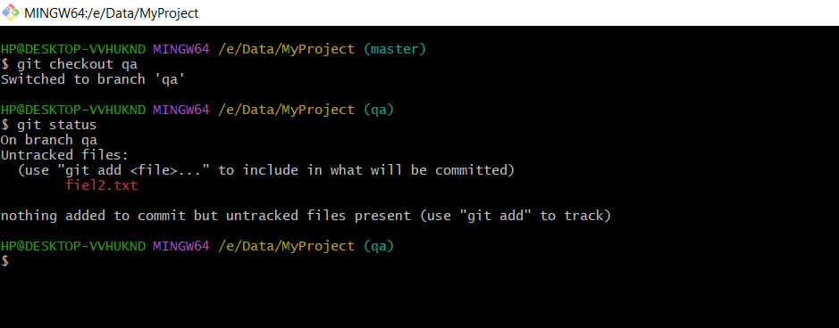

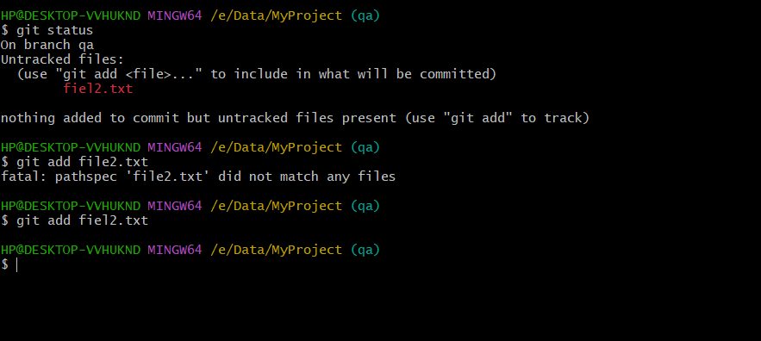

#. Commit file2.txt

